Analysis of the Relationship Between Rainfall, Temperature and Maize Yield in Kenya
Phase 2 Analysis Report | Agriculture | 2010–2024

1. Title and Group Members
Analysis of the Relationship Between Rainfall, Temperature and Maize Yield in Kenya
- 1034809 – Patrick Muasya
- 1060626 – Rotich Kipyegon
- 1061032 – Kevin Kiplagat
- 1062548 – Upao Mazibo
- 1062554 – Hailu Samuel Dabaly
- 1068671 – Hope Wanjiru

2. Introduction and Research Questions
Maize is a major food crop in Kenya and supports household food supply and livelihoods. Annual maize yield varies, while rainfall and temperature also change from year to year. This phase applies the data collection and analysis plan from Phase 1 to examine how national annual climate measures are associated with maize yield. The analysis combines agricultural and climate records for the common period 2010–2024, summarizes trends, and uses correlations and a multiple linear regression model to describe the observed relationships.
The analysis answers four questions: How did maize yield change from 2010 to 2024? What association is visible between annual rainfall and yield? What association is visible between annual mean temperature and yield? How well do rainfall and temperature together account for variation in annual maize yield in this sample?
The analysis is exploratory. Because it contains only 15 national annual observations and omits many agricultural influences, its results describe associations in this dataset and do not establish that climate caused yield changes.

3. Data Sources and Variables
The analysis uses annual secondary data for Kenya over 2010–2024 inclusive, giving 15 observations. FAOSTAT supplied maize harvested area and yield; the World Bank Climate Change Knowledge Portal (CCKP) supplied annual rainfall and mean temperature; the Kenya National Bureau of Statistics (KNBS) Economic Survey is retained as official context for interpreting national agriculture trends. The analysis dataset was assembled from the project’s agricultural CSV and CCKP JSON series.
Variable | Definition in this analysis | Unit / role
Year | Calendar year identifying each annual record | 2010–2024; join key
Maize yield | Maize output per harvested area | tonnes per hectare (t/ha); outcome
Annual rainfall | Annual total precipitation for Kenya | millimetres (mm); explanatory
Annual mean temperature | Annual mean surface air temperature for Kenya | degrees Celsius (°C); explanatory
Maize harvested area | Area harvested for maize | million hectares (million ha); descriptive/context

4. Data Cleaning and Preparation
The maize data were read from the supplied FAOSTAT export. The year field was converted to an integer, and harvested area and yield were converted to numeric values. The rainfall and temperature JSON series were converted into year/value records. Where a climate series contained multiple date entries within a year, its values were averaged to produce one annual value per year.
The three sources were matched by year using inner joins, keeping years represented in all sources. Variable names were standardized to year, maize_area_million_ha, maize_yield_t_ha, annual_rainfall_mm, and annual_mean_temp_c, with the units retained in the names where useful. The merged data were sorted by year and saved as kenya_maize_climate_clean.csv. Checks included row count and year range, missing values, duplicate years, non-positive or unusually high yields, negative rainfall, and temperatures outside a broad 10–35 °C review range. The resulting analysis file contains 15 consecutive annual records from 2010 through 2024.
Annual aggregation supports a national year-to-year comparison but removes seasonal and regional detail. A single annual mean also cannot show when within the crop calendar rainfall or heat occurred.

5. Exploratory Analysis and Results
Across the 15 years, maize yield ranged from 1.43 to 1.82 t/ha and averaged 1.646 t/ha. Annual rainfall ranged from 627.2 to 1,146.5 mm, with a mean of 848.4 mm. Annual mean temperature ranged from 24.84 to 25.55 °C, averaging 25.19 °C. Harvested area ranged from 2.01 to 2.43 million ha and averaged 2.193 million ha.
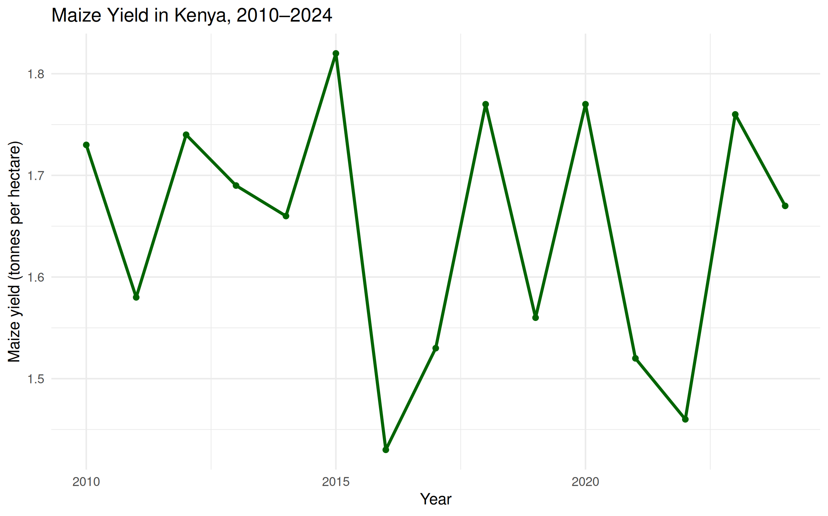
Figure 1. Maize yield in Kenya, 2010–2024.
Yield fluctuates across the period rather than moving steadily in one direction. It reaches a low of 1.43 t/ha in 2016 and a high of 1.82 t/ha in 2015; the final year, 2024, is 1.67 t/ha.
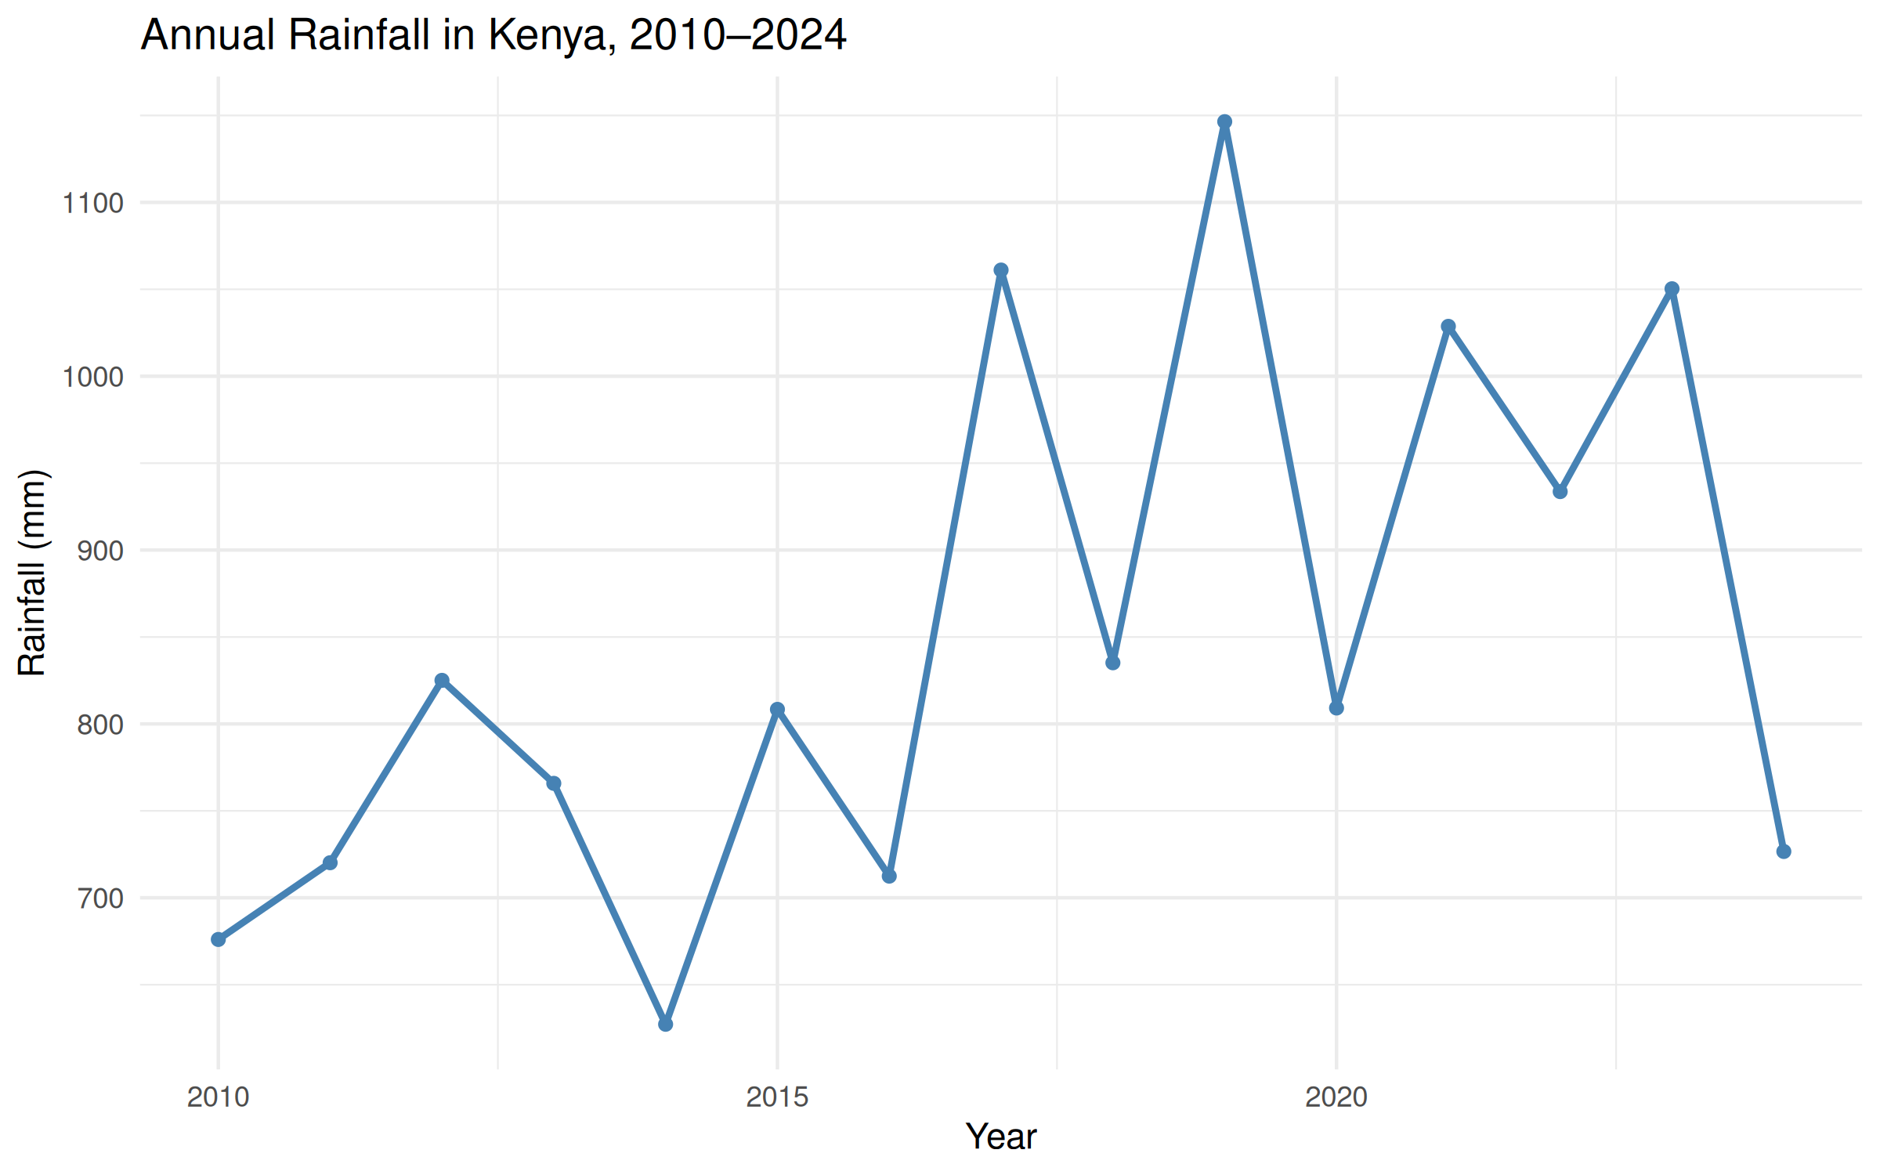
Figure 2. Annual rainfall in Kenya, 2010–2024.
Rainfall varies substantially between years. It is lowest in 2014 (627.24 mm) and highest in 2019 (1,146.45 mm), then falls to 726.63 mm in 2024.
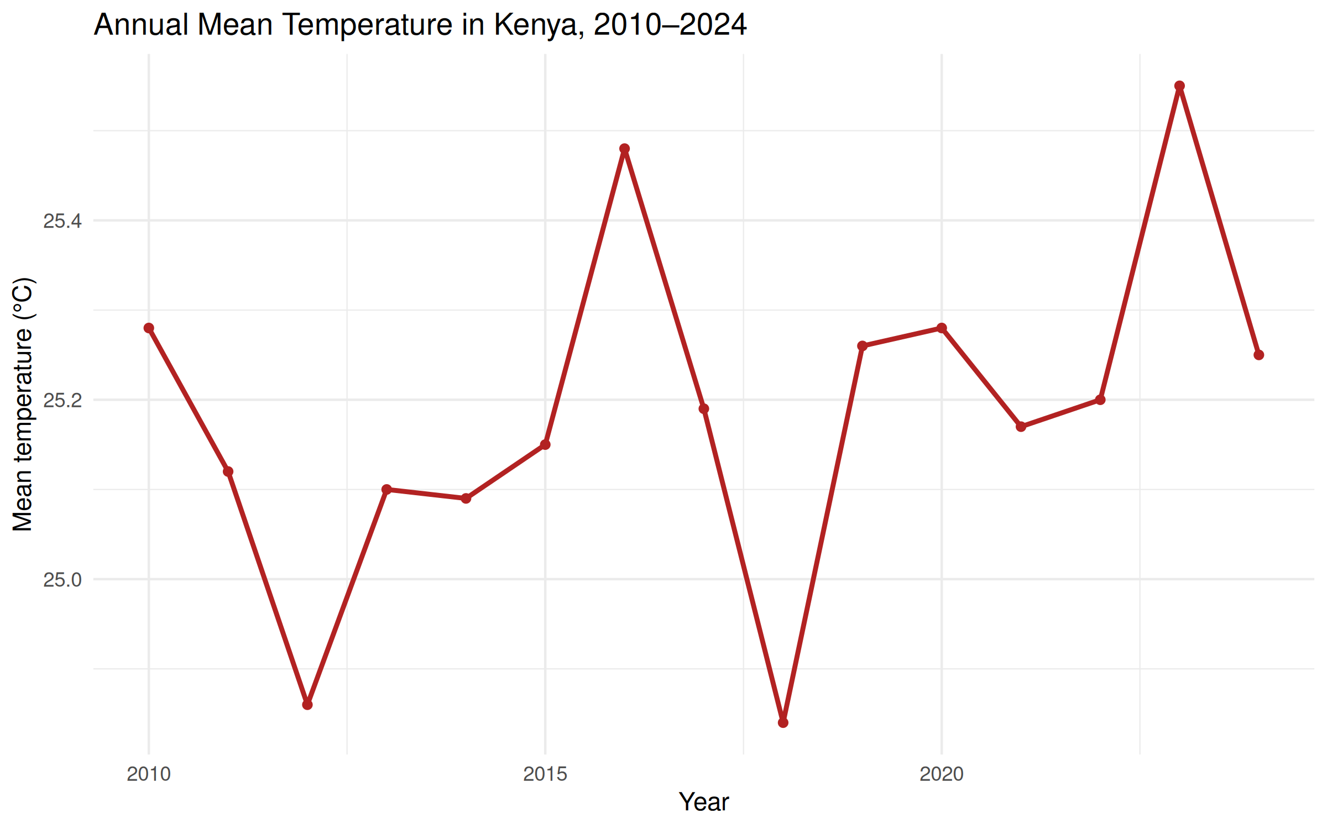
Figure 3. Annual mean temperature in Kenya, 2010–2024.
The plotted annual means stay within a relatively narrow range, from 24.84 °C (2018) to 25.55 °C (2023). Temperatures vary year to year, with warmer observations in 2016 and 2023.
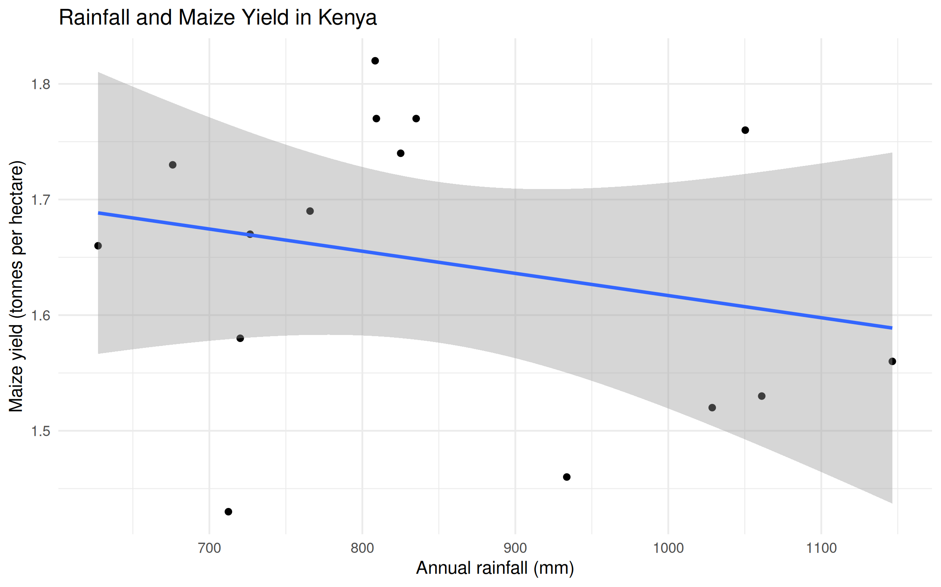
Figure 4. Annual rainfall and maize yield.
The points are broadly dispersed, with a slight downward direction overall: some of the wetter years have yields below the sample average, while yields at similar rainfall levels still differ. The graph alone does not establish a statistically reliable relationship.
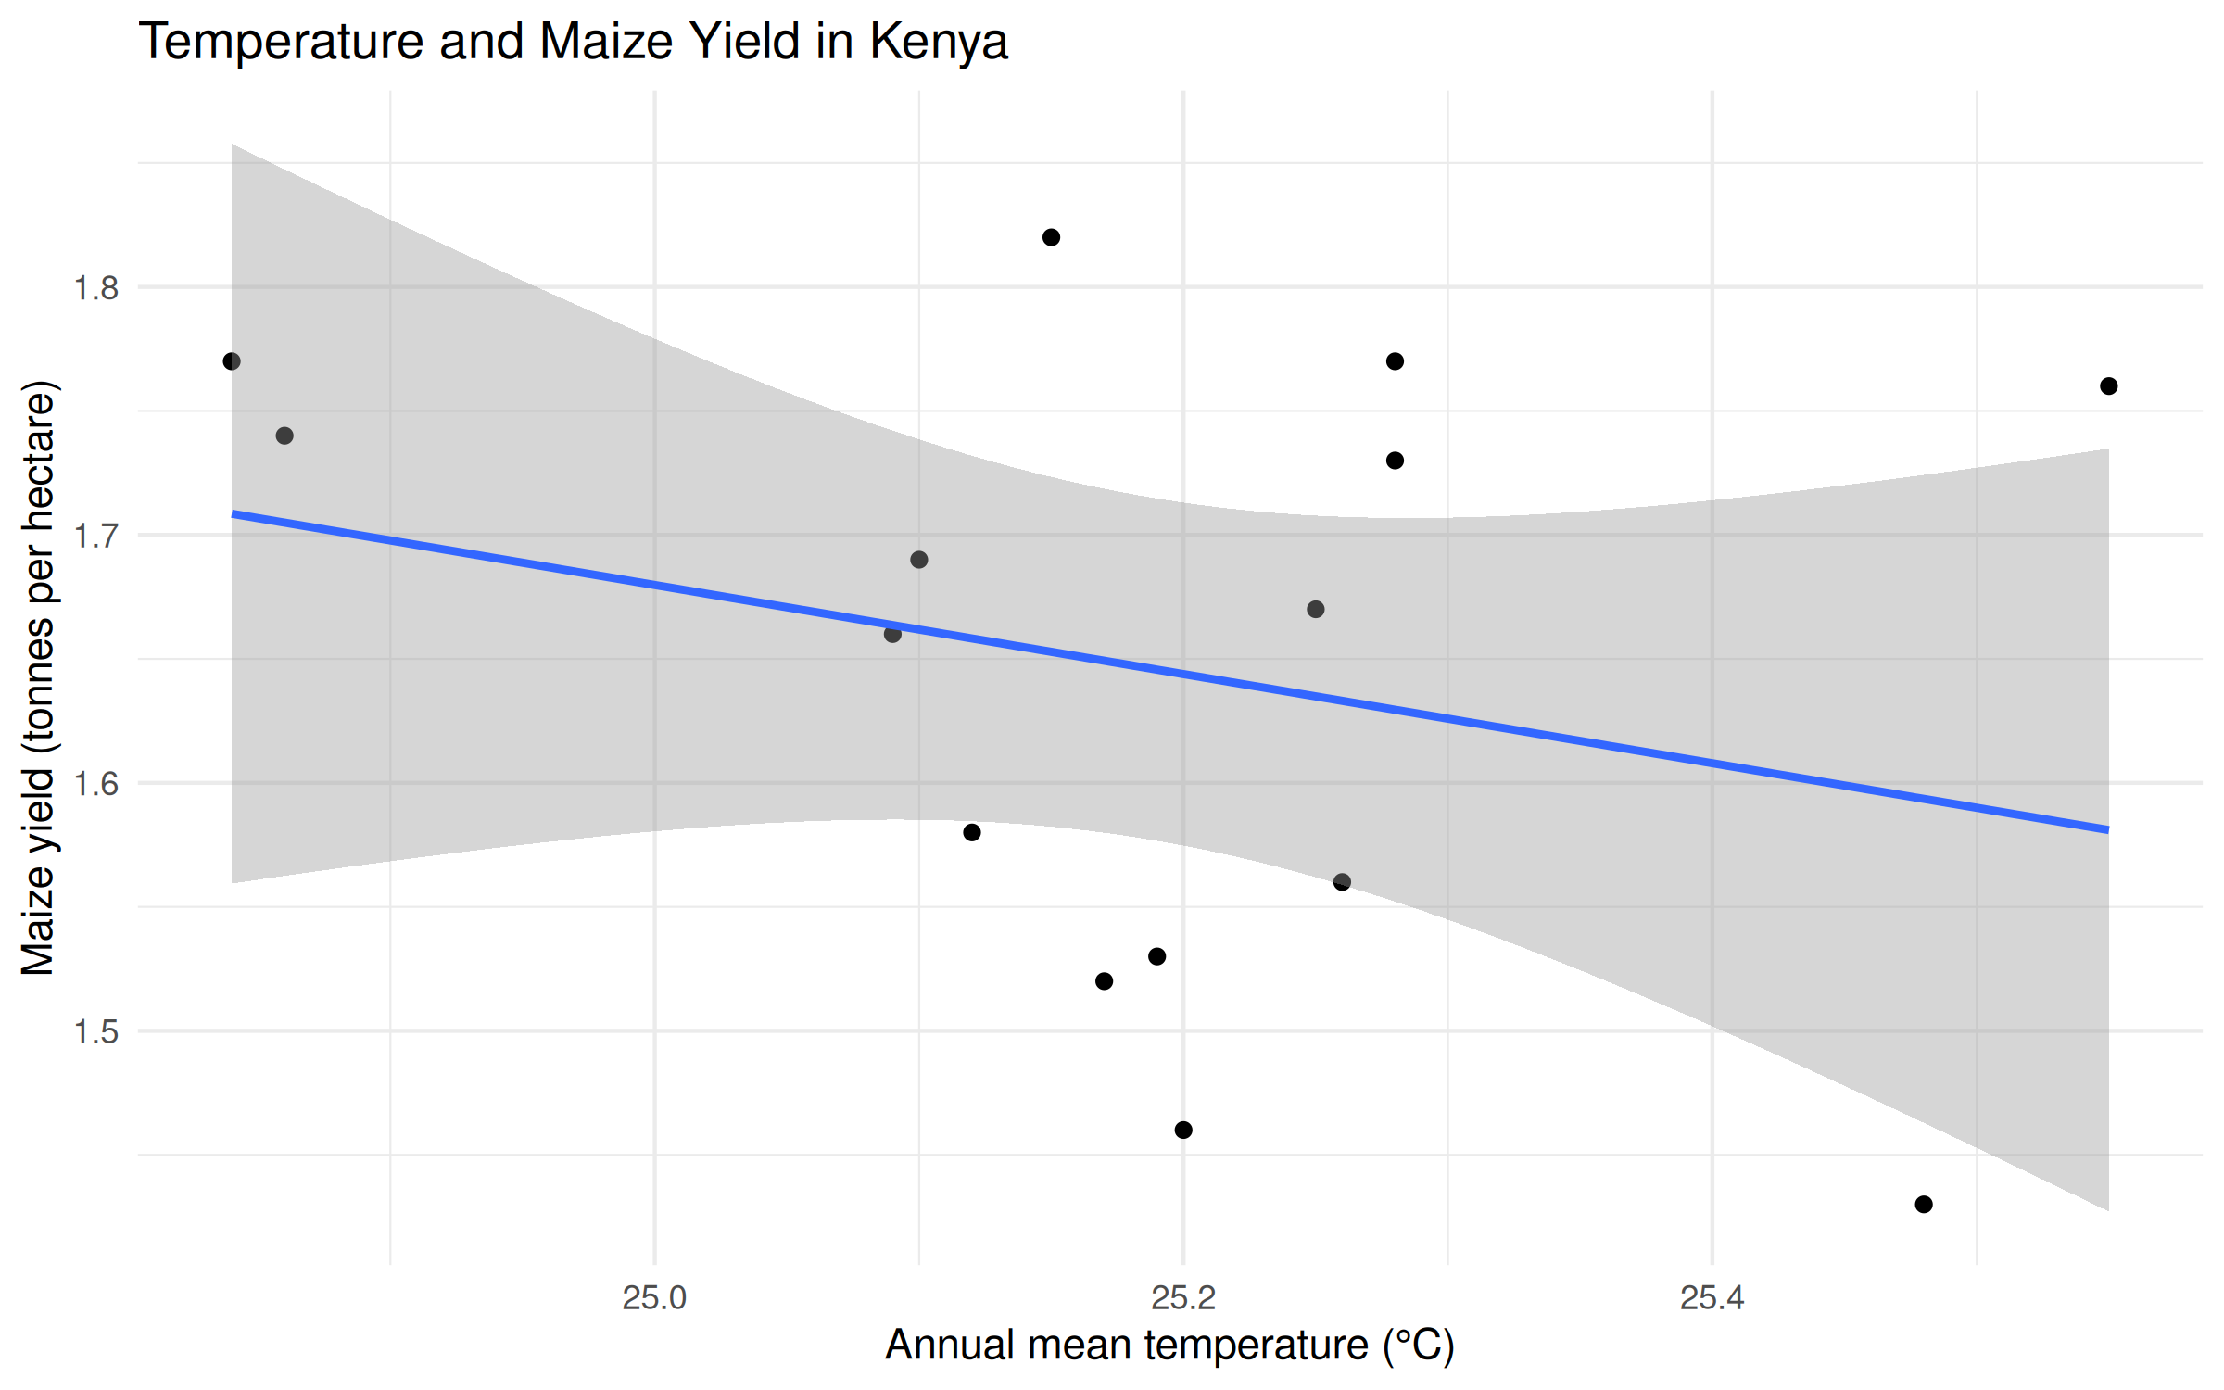
Figure 5. Annual mean temperature and maize yield.
The points show a weak downward tendency but are widely spread, especially because several different yields occur at similar temperatures. This visual pattern alone does not establish a statistically reliable relationship.

Correlation results
Pearson correlation between rainfall and maize yield was r = −0.246 (p = 0.3769; n = 15). The estimate indicates a weak negative linear association in this sample: higher annual rainfall tended to occur alongside somewhat lower yields, but the observations are widely scattered and the p-value does not provide evidence against a zero linear correlation at conventional thresholds.
Pearson correlation between annual mean temperature and maize yield was r = −0.273 (p = 0.3256; n = 15). This is also a weak negative linear association in the sample. The p-value likewise does not provide evidence against a zero linear correlation at conventional thresholds. These p-values do not prove that no relationship exists; the small sample limits precision.

Multiple regression results
A multiple linear regression predicted maize yield from annual rainfall and annual mean temperature. The estimated equation was: yield (t/ha) = 5.684 − 0.0001578 × rainfall (mm) − 0.154986 × temperature (°C).
Term | Coefficient | p-value
Intercept | 5.6837 | 0.236
Rainfall (per 1 mm) | −0.0001578 | 0.478
Temperature (per 1 °C) | −0.1549860 | 0.412
Holding temperature constant, the rainfall coefficient corresponds to an estimated 0.0001578 t/ha lower yield per additional millimetre (about 0.158 t/ha per 1,000 mm); its p-value is 0.478. Holding rainfall constant, the temperature coefficient corresponds to an estimated 0.155 t/ha lower yield per 1 °C; its p-value is 0.412. These are model-based conditional associations, and the estimates are uncertain in this small dataset.
The model R² is 0.1139 (adjusted R² = −0.03378): rainfall and temperature together account for about 11.4% of the observed in-sample variation in yield, while the adjusted value indicates that the model does not improve on a simple mean prediction after accounting for the two predictors. The overall model p-value is 0.4841. The output therefore does not show strong predictive performance in this sample.

6. Limitations
- The dataset has only 15 annual observations at the national level. It cannot represent differences among counties, farms, or maize-growing zones, and a small sample makes estimates sensitive to individual years.
- Annual national rainfall and temperature summarize conditions across time and space. They do not capture seasonal timing, dry spells, extreme heat, or local conditions during critical crop growth stages.
- Yield also depends on factors not included in the model, including seed varieties, soil, pests and disease, fertilizer and other inputs, irrigation, farming practices, and market or policy conditions. Omitted factors may influence both weather exposure and yields.
- The bivariate correlations and linear regression describe associations under simple statistical assumptions. They do not establish causation, and the fitted coefficients should not be interpreted as causal effects or reliable forecasts.

7. Conclusion
For Kenya’s 2010–2024 national annual data, yield varied between 1.43 and 1.82 t/ha. Rainfall and temperature each had weak negative sample correlations with yield, and both regression coefficients were negative, but their p-values were 0.478 and 0.412. The two-predictor model had R² = 0.1139 and overall p = 0.4841, so it accounted for a limited share of observed yield variation and showed limited predictive value here. These findings answer the exploratory questions for this dataset, while the small national annual sample can show associations only; it cannot prove that climate caused yield changes. A future analysis could use county or season-level data and include agronomic and input variables to represent the production process more fully.

8. References
- Food and Agriculture Organization of the United Nations. (2025). Crop production, yield, harvested area (Global, National – Annual), FAOSTAT. https://data.fao.org/catalog/iso/d24a448b-3b62-4c09-8c1d-4a39bb599876
- Food and Agriculture Organization of the United Nations. (2026). FAOSTAT: Food and agriculture data. https://faostat.fao.org/
- Kenya National Bureau of Statistics. (2025). 2025 Economic Survey. https://www.knbs.or.ke/reports/2025-economic-survey/
- Kenya National Bureau of Statistics. (2026). 2026 Economic Survey. https://www.knbs.or.ke/reports/2026-economic-survey/
- World Bank. (2026). Climate Change Knowledge Portal: Kenya – Historical Climate. https://climateknowledgeportal.worldbank.org/country/kenya/climate-data-historical
- Central Bank of Kenya. (2024). Agriculture Sector Survey of March 2024. https://www.centralbank.go.ke/2024/04/09/agriculture-sector-survey-of-march-2024/

